SCHOOL OF PHILOSOPHY
National and Kapodistrian University of Athens
International Conference 8-11 december 2021

“Through the Pen of Others: Nineteenth-Century Views of Revolutionary Greece”

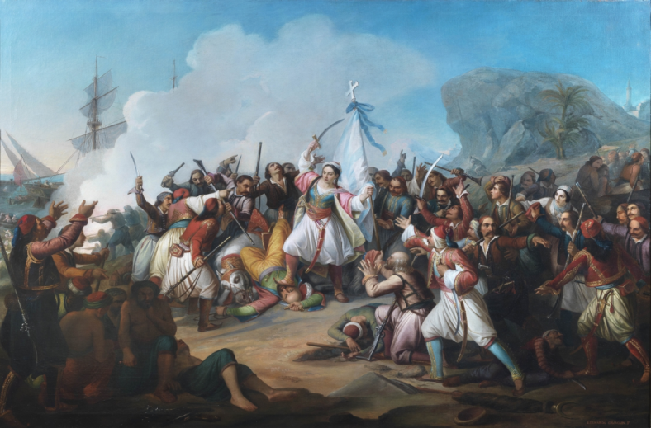

Revolutionary Greece embodied humanist values for many foreigners throughout the 19th century, a time in which the ideals of independence, freedom, self-determination and solidarity were gaining ground in Europe. From the destruction of Souli in Epirus and the 1821 Revolution, to the Cretan Revolt and the 1897 Greco-Turkish war, the Greek struggle inspired many foreign writers, artists, musicians and playwrights, and influenced popular and material culture, as well as fashion. The European and international press recorded and analysed the dramatic events, profiled the protagonists and shaped the perception of the Greek national cause, even as political opinion may have been sceptical or at times hostile.

Greece became the place where imagination and politics met, a dreamlike and often contradictory land of revolution that defined the pen of others and their views of the central issues of the nineteenth century, such as freedom and bondage, revolution and colonialism, Empire and the Orient. The consolidation of the classical ideal, together with the movements of Romanticism and Philhellenism, shaped the image of revolutionary Greece as guarantor of its own and Europe’s enlightened past, which in turn clashed with its present reality.

This conference aims to expand both our knowledge of the reception of revolutionary Greece in the nineteenth century and the ways in which it contributed to the formation of a national “character” and political and cultural stereotypes that may still be at play two centuries later.

Thematic axes

1. Literature: the impact of the revolution and the founding of the Greek state
Greece in revolt is a prevalent theme in nineteenth-century European and world literatures (poetry, drama, fiction), both in the texts of important poets and authors and in the widely read contemporary popular literature. Such texts include works of fiction as well as life writing: the memoirs and correspondence of the Philhellenes, who participated in the independence struggle, and travel writing. This axis seeks to examine literary reflections of Greece in national literatures as well as comparative analyses.

2. Academic discourse
The Greek affair quickly became an academic pursuit. Historians and scholars from many disciplines, especially philologists and folklorists, studied the modern culture of Greece, sometimes using the examination of folk songs, customs and habits, costumes and language to support the Greek cause. This axis aims to explore debates in academic Philhellenism focusing on their ideological tenets.

3. The international press
Greece was regularly present in the European and international press through political articles written for or against the Greek struggle, information on the developments in Greece and connection to European affairs. This axis wishes to examine the variety of opinions expressed in sources such as nineteenth-century newspapers and magazines which placed revolutionary Greece in the international political context.

4. Music and the visual and performing arts
The Greek cause was an inspiration to arts other than literature. This axis seeks to explore nineteenth-century musical and visual works inspired by Greek battles or “heroes and heroines” of the Revolution as well as those representing Greece as a newly formed state. It will also consider intermedial approaches and engage in a comparative dialogue that will highlight analogies between literature and the visual and/or performative arts.

5. Material culture
This axis aims to examine the production of everyday objects decorated in Philhellenic patterns (clocks, ornaments, porcelain, caskets, fans, medals, etc.) and the focus on Greek costumes that influenced European fashion.

6. “Heroes and Heroines”: Gendered identities— women’s writing
This axis will explore women’s writing focusing on the theme of revolutionary Greece and will contextualise the literary representations of “heroes and heroines” in the light of gender theory.

7. New literary myths about Greece and its Other
Philhellenic literature has mythologized several revolutionary figures (Markos Botsaris, Konstantinos Kanaris, Souliotissa) and heroic places (Missolonghi, Souli, Chios). Inspired by historical events and occasionally linked to ancient Greece, such figures and places come across as abstract and transhistorical, bearing mythical qualities. This axis will invite reflection on the creation of new Philhellenic myths that was accompanied by the stereotyping of the enemy and the construction of a negative mythology of the Other.

8. The formation of national identities
This axis examines the formation of Greek national identity within the historical context of the nineteenth century and its representation in literature, academic discourse and the press. It also seeks to investigate the relevant Philhellenic discourse which often includes the Philhellenes’ own political demands during and in the wake of the Greek affair.

Submission deadline: 28 February 2021. A title, an abstract of no more than 300 words and a short biographical note should be sent to: 200etielladaFLSekpa@phil.uoa.gr

Paper duration: 20 mins.

Proposal acceptance: 31 March 2021

Contact: 200etielladaFLSekpa@phil.uoa.gr

Conference webpage: https://conferences.uoa.gr/e/ellada200flsekpa

Publication instructions: Sent upon proposal acceptance.

Fees: 60 euro for speakers & 10 euro for students (certificate of attendance and full conference dossier included).

Languages for submissions: Greek, English, French, German, Italian, Spanish, Russian.

The conference will take place from 8 to 11 December 2021 at the central building of the National and Kapodistrian University of Athens (30 Panepistimiou Street).

The Scientific Committee
Chair: Achilleas Chaldaeakes (Dean, Department of Music Studies)
Vice-Chair: Ioannis Dim. Tsolkas (Department of Italian Language & Literature)
Members: Efterpi Mitsi (Department of English Language & Literature)
Despina Provata (Department of French Language & Literature)
Anastasia Antonopoulou (Department of German Language & Literature)
Roubini Dimopoulou (Department of Italian Language & Literature)
Spyridon Mavridis (Department of Spanish Language & Literature)
Nikolaos Maliaras (Department of Music Studies)
Evanthia Stivanaki (Department of Theatre Studies)
Olga Alexandropoulou (Department of Russian Language & Literature and Slavic Studies)

Painting: Leonardo Gavagnin (Venezia 1809-1887), Episodio delle lotte per l’indipendenza della Grecia dall’Impero Ottomano.

